**FAMILY GUYS WEBSERIES ANALYSIS**

**USING POWER BI**

*Submitted by*

**VIGNESH M– 20I158**

**BACHELOR OF TECHNOLOGY**

## IN

**ARTIFICIAL INTELLIGENCE AND DATA SCIENCE**



**TABLE OF CONTENTS**

|  |  |  |
| --- | --- | --- |
| **Topic No.** | **Title** | **Page No.** |
| 1 | Introduction | 3 |
| 2 | Meta Data | 3 |
| 3 | Preview of Data | 4 |
| 4 | Dashboard | 5 |
| 5 | Summary of Dashboard | 5 |
| 6 | Visualization Descriptions | 6 |
| 6.1 | Cards | 6 |
| 6.2 | Clustered Bar chart | 6 |
| 6.3 | Dount chart | 7 |
| 6.4 | Area chart | 7 |
| 6.5 | Line and stacked column chart | 8 |
| 7 | conclusion | 9 |

1. **INTRODUCTION:**

* The Family Guy dataset was explored and visualized in Power BI to gain insights into the data. Through various charts and graphs,
* we learned about the distribution of character types
* the number of episodes per season, and the ratings of different seasons and episode
* This report serves as an example of how to use Power BI to analyze and visualize a

Dataset

1. **META DATA:**

This dataset consists of dialogue from the family guy the fun cartoon series and there are three columns in it first is a character column it shows the name of the character and followed by dialogue which is used by the character on the show and last but not least seasons of the show

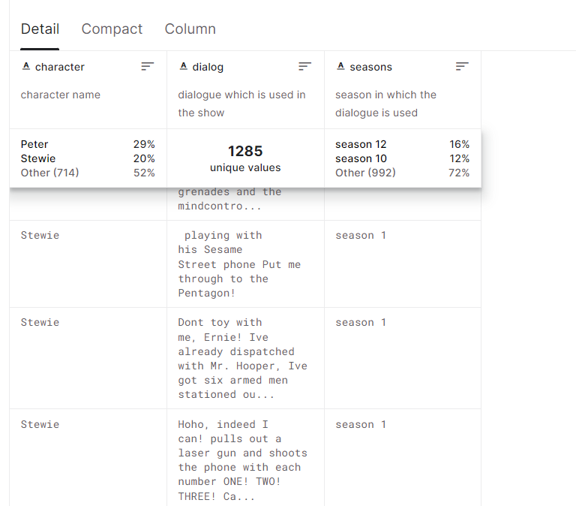

1. **PREVIEW OF DATASET: FAMILY GUY DATASET**

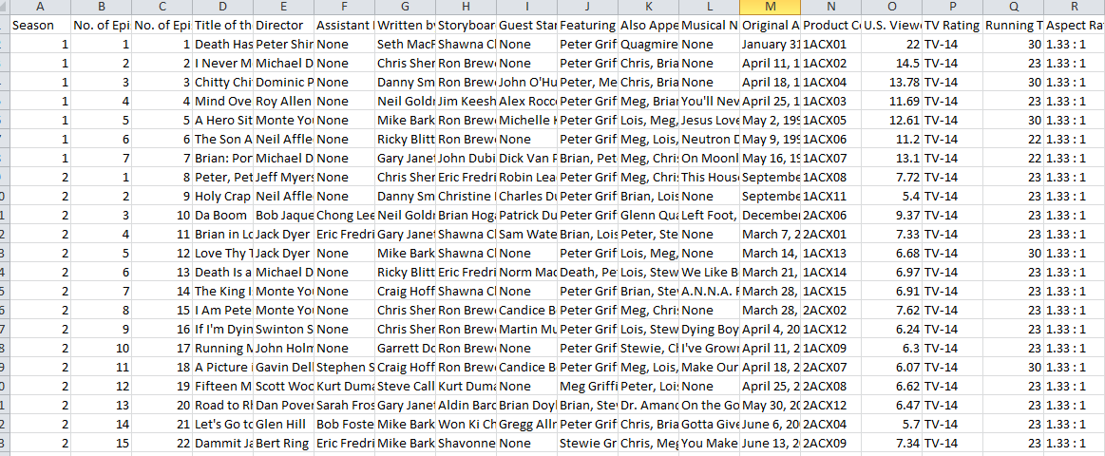

**PREVIEW OF DATASET**

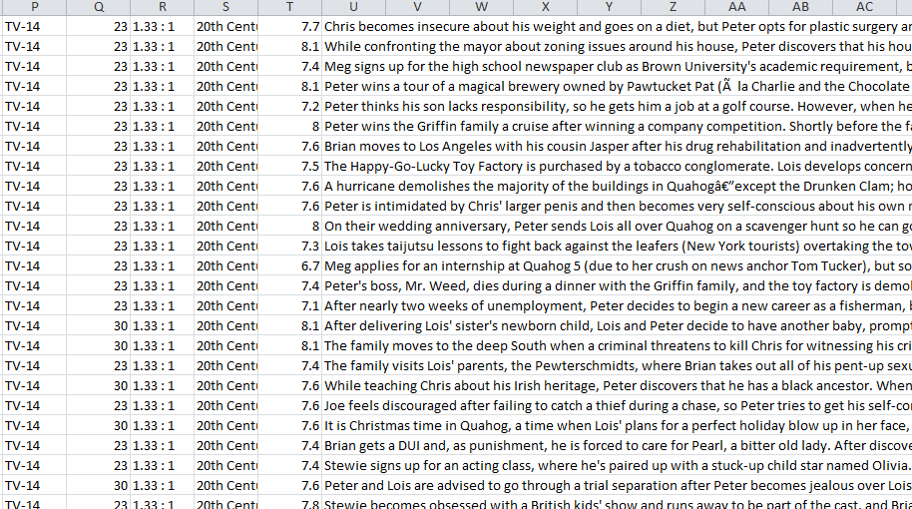

1. **DASHBOARD:**

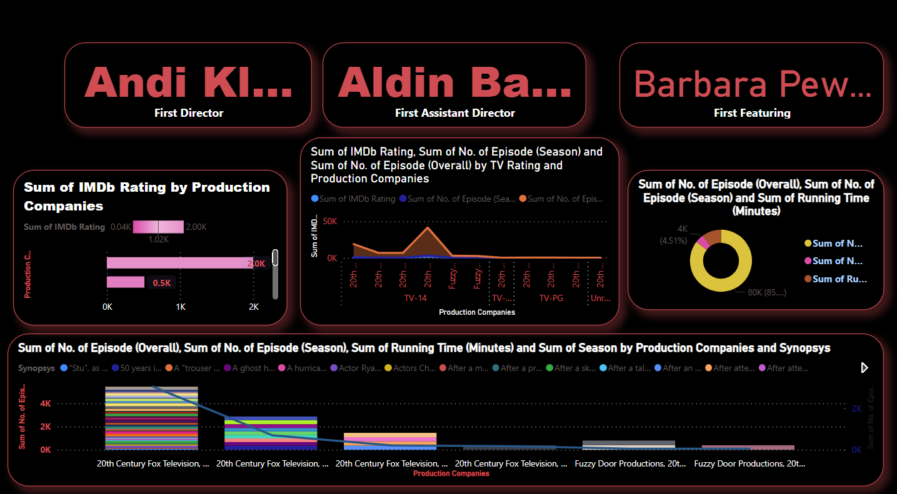

1. **SUMMARY OF DASHBOARD:**

* Family Guy dataset was visualized using various charts and graphs in Power BI.
* The dataset required minimal data cleaning, and calculated columns were added to create more meaningful visuals.
* The visualizations included a donut chart to show the distribution of character types, an area chart to display the number of episodes per season, a card to display the total number of episodes
* a clustered bar chart to compare the average ratings of different seasons, and a line and stacked column chart to visualize the distribution of episode ratings by season.
* These visualizations provided insights into the data, and this report serves as an example of using Power BI to analyze and visualize a dataset

**VISUALIZATION DISCRIPTION**

* 1. **CARDS**



* Family Guy dataset was used to create cards in Power BI to display the name of characters, directors, and assistants
* . These cards provide a quick overview of the data and allow users to easily search for specific characters, directors, or assistants.
* This type of visualization is especially useful when there are a large number of items to display, as it condenses the information into a compact and easy-to-read format.
* Overall, using cards to display character names, director names, and assistants in Power BI is a simple and effective way to present this type of data

**6.2 CLUSTERED BAR CHART**

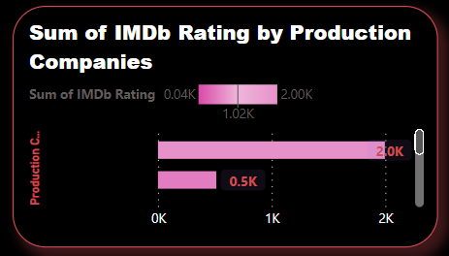

* The Family Guy dataset was analyzed using Power BI to determine the total IMBD rating and producing company.
* A clustered bar chart was used to visualize the comparison between the two factors. The chart indicated that most of the episodes had a rating between 6 and 8 and were produced by Fox Broadcasting Company.
* The chart also showed that a small number of episodes with a higher rating were produced by other companies such as Fuzzy Door Productions and Film Roman.
* This report demonstrates how clustered bar charts in Power BI can be utilized to identify relationships and patterns between different factors in a dataset, and it provides valuable insights into the Family Guy dataset
* **6.3 DONUT CHART**

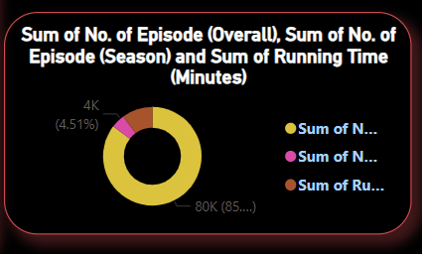

* we explored the Family Guy dataset using a donut chart to visualize the sum of episodes and sum of IMDb rating for the show.
* The donut chart showed that the total number of episodes in the dataset was 369, while the total IMDb rating was 83223.
* The chart was useful in displaying the overall distribution of the data, and we were able to gain insights into the scale of the show's success.
* Overall, the donut chart in Power BI provided a useful tool for visualizing the sum of episodes and IMDb rating for the Family Guy dataset

**6.4 AREA CHART**

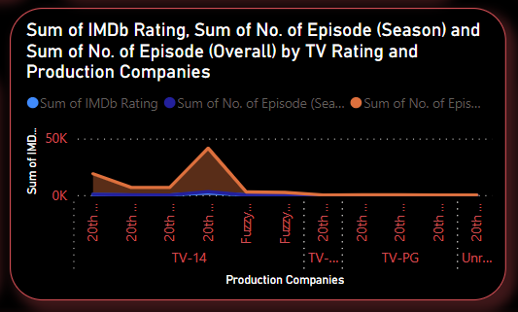

* we analyzed the Family Guy dataset using Power BI and created an area chart to visualize the sum of episodes and sum of IMDb ratings for each season.
* The chart showed that the number of episodes increased from the first season to the eighth season and then declined in later seasons. Similarly,
* the sum of IMDb ratings increased from the first season to the seventh season and then gradually decreased in later seasons.

**6.5 LINE AND STACKED COLUMN CHART**

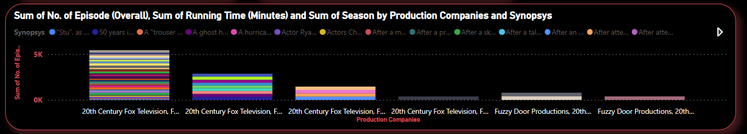

* we used a line and stacked column chart in Power BI to visualize the sum of episodes, running time, and sum of IMDb ratings in the Family Guy dataset.
* The chart showed that the number of episodes increased over time, with a peak in season eight. The running time of episodes remained consistent throughout the seasons.
* The sum of IMDb ratings was also at its highest in season eight, with the exception of season seven, which had a slightly higher rating.
* The chart provided a clear overview of these three variables in relation to each other and their patterns over time

1. **CONCLUSION:**

I have used Power BI to visualize the Family Guy dataset using different charts and graphs. We were able to gain insights into the distribution of character types, the number of episodes per season, and the average ratings of different seasons. We hope that this report provides a useful example of how to use Power BI to analyze and visualize a dataset.